USDA Forest Service

Alaska Region, Law Enforcement & Investigations

DETAIL OUTREACH NOTICE

Program Specialist, GS-0301-09/11
The USDA Forest Service, Alaska Region, Law Enforcement & Investigation (LEI) is seeking a candidate for a Program Specialist, GS-0301-09/11. This is a full time, permanent position. The purpose of this Outreach Notice is to inform prospective applicants of this upcoming opportunity. To express interest in this position, please complete the attached Outreach Notice and return to Special Agent in Charge, Tim Walther at tim.walther@usda.gov or via FAX 907-586-8780 by close of business on March 12, 2019.

Brief description of duties associated with this position:
The position is located in Juneau, Alaska. The Program Specialist will provide budget, administrative, and management support to Law Enforcement & Investigation Regional Office Staff and Forest Supervisory Law Enforcement Officers.
Please contact Tim Walther at 907-586-8820 if you have questions.

About Location:

For information about duty station:

http://juneau.com/
.

How to apply:
The purpose of this Outreach Notice is to determine the potential applicant pool for this position and to establish the appropriate recruitment method and area of consideration for the advertisement. If you are interested in applying for this position, complete the attached Outreach Notice Response Form and return it to Tim Walther at mailto: tim.walther@usda.gov or via FAX 907-586-8780 no later than March 12, 2019.
This outreach form does not constitute an application. The vacancy announcement will appear on the USAJOBS website. USDA is an equal opportunity provider and employer.

Outreach Response Notice Sheet
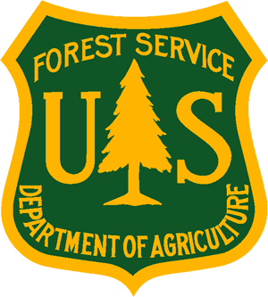
Program Specialist, GS-0301-09/11
USDA Forest Service, Alaska Region, Law Enforcement & Investigation
Duty Station: Juneau, Alaska
Please submit outreach response to Tim Walther by close of business March 12, 2019.
Email: tim.walther@usda.gov Phone: 907-586-8820 Fax: 907-586-8780.

Name:
Date:
Mailing Address:
Phone:
E-Mail:
Are you a current Federal employee? Yes No
If you answered “yes” to the question above
Current agency employed with:
Enter your current position title:
Series:
Grade:
Location:
Indicate the type of appointment you are currently under:
(Career, Career-Conditional, Excepted, Excepted VRA, Temporary, Term, PWD, Other)
How did you find out about this outreach notice?
If you are not a current permanent (Career or Career-Conditional) employee, are you eligible to be hired under any of the following special authorities?
Person with disabilities Disabled veteran with 30% compensable disability
Veterans Recruitment Act Veterans Employment Opportunities Act of 1998
Pathways Program Former peace Corps Volunteer
Thank you for your interest in our vacancy.
USDA is an equal opportunity provider and employer.

