OUTREACH NOTICE

Ochoco National Forest/Lookout Mountain Ranger District
and Crooked River National Grassland
Fisheries Biologist, GS-0482-09/11
PERMANENT FULL-TIME

The Ochoco National Forest/Lookout Mountain Ranger District and Crooked River National Grassland will soon be advertising and filling a Fisheries Biologist position, GS-0482-09/11, stationed in Prineville, Oregon.

PLEASE NOTE: The purpose of this Outreach Notice is to determine the potential applicant pool and to establish the appropriate recruitment method and area of consideration for the advertisement. (e.g., target grade or multi-grade and service-wide, region-wide government-wide, or DEMO). Responses received from this outreach will be used to make this determination. If you are interested, Please Respond to the Outreach on the form, below.

All interested applicants of the permanent position will be notified of the vacancy announcement number and closing date when it becomes available. The vacancy announcement for this position, when open, will be posted at the USA Jobs website, the U.S. Government’s official site for jobs and employment information: http://www.usajobs.opm.gov

If you are interested in this position, please send the outreach response form included at the end of this notice to Slater Turner, Lookout Mountain and Crooked River National Grassland District Ranger at slater.turner@usda.gov by close of business on July 31, 2020.

THE POSITION:

We are looking for an individual who:
- Has strong interpersonal skills
- Is a good communicator, both written and oral
- Is technically competent with a solid foundation in freshwater fish biology and aquatic restoration
- Is a team player who enjoys working with others to accomplish a common goal
- Is a self-starter, enjoys a challenge and has excellent problem-solving skills
- Has the ability to cope well with changing direction, multiple priorities, and a fast-paced work environment
- Has the ability to work well with diverse groups of people

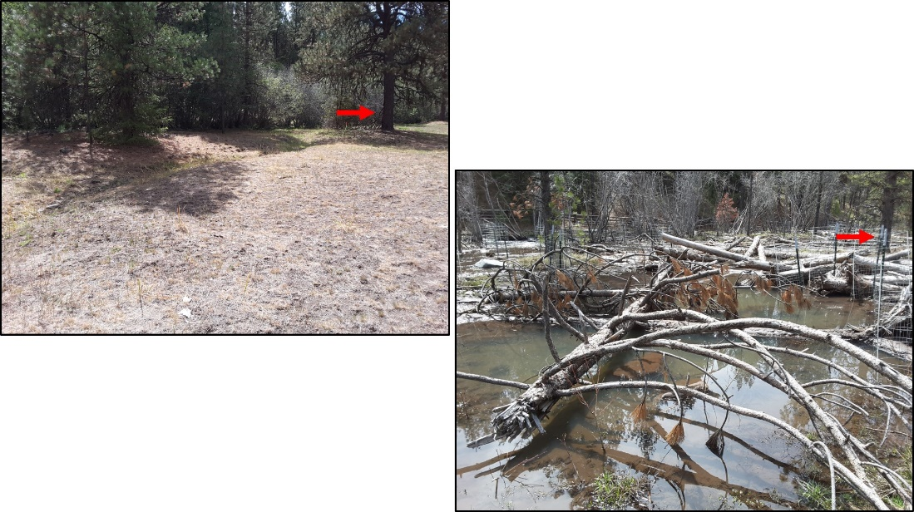
Before (left photo) and after (right photo) of McKay Floodplain Restoration Project on the Ochoco National Forest.

Description of Primary Duties:
This Fisheries Biologist position provides fisheries and aquatic expertise and support related to aquatic restoration (see above photos!), environmental planning, and program management for the Lookout Mountain Ranger District on the Ochoco National Forest and the Crooked River National Grassland. Specific duties are varied and challenging, including:

- Oversight of a growing and challenging aquatic restoration program
  - The Ochoco NF has amazing opportunities to improve aquatic habitat including many cutting edge projects involving meadow restoration, channel cut and fill, headcut repair, large wood addition, and fish passage improvement.
- Supervising two seasonal biological technicians on the stream survey crew.
- Integral interdisciplinary team member for a variety of planning projects ranging from aquatic restoration, forest health and fuels reduction, recreation, and range.
- Managing the fisheries program for the Lookout Mountain Ranger District and Crooked River National Grassland and working in conjunction with the District hydrologist as part of the Aquatics team to develop project prioritization and scheduling, some budget analysis and tracking, working with a diverse array of partners to increase project funding and capacity, and serving on the district leadership team.
- Participating in various environmental education programs

The direct supervisor of this position is the District Ranger.

ABOUT THE PRINEVILLE AREA

The City of Prineville is located 35 miles northeast of Bend and 30 miles southeast of Madras. The major highway through town is US Highway 26. The population is around 9,200 in the city with approximately 23,000 living in the surrounding area. There are numerous facilities in and adjacent to town, including: parks and outdoor recreational areas, a public library, full service medical and dental facilities, a shopping center, two golf courses, and numerous churches of various denominations.
SCHOOLS: Crook County School District has eight schools: one high school; one alternative high school and other alternative programs; one middle school; four elementary schools; and one charter school. Central Oregon Community College in Bend offers two-year programs as well as four-year degrees through Oregon State University and the University of Oregon. OSU Crook County Open Campus works to bring educational credit and non-credit classes from Oregon State University, Central Oregon Community College, OSU Cascades, and other institutions of higher education to Crook County.
HEALTH CARE: Prineville is home to Pioneer Memorial Hospital, which is a member of the regional St. Charles Healthcare organization. PMH is a fully accredited, critical-access hospital, licensed for 25 beds and capable of handling all routine and emergency medical matters. The hospital offers a comprehensive range of services, including laboratory and diagnostic imaging services. The hospital’s Emergency Department is open 24/7 and rated trauma Level IV. The hospital’s surgery unit and intensive care units are highly skilled and trained. In extreme cases, the hospital works closely with AirLink Critical Care Transport and St. Charles Hospital in Bend. There is also a family birthing center, extended care program, a home health care program and hospice care offered through the hospital. Prineville is also home to two clinics.

HOUSING: Rental apartments and houses are available in Prineville. The approximate range for the monthly cost of rentals is $500-$800 for a two bedroom, one bath unit and around $650-$1000 for a three bedroom unit in either duplexes or apartments. The cost for a three bedroom single-family house runs $750 and up.

Prineville is a rapidly growing community with many new subdivisions. The average price for a newer home in Prineville is $190,000 - $250,000, and for a single-family residence on rural acreage $150,000 - $300,000 and up. The value of rural property is determined to a large extent on the availability of water.

TRAVEL: Prineville is 18 miles from Robert’s Field, the regional municipal airport in Redmond, OR, which offers daily commercial flights to a variety of locations, including: Portland International Airport (PDX); Seattle International Airport (SEA); San Francisco International Airport (SFO); Denver International Airport (DEN); Salt Lake International Airport (SLC); and Phoenix Sky Harbor International Airport (PHX).

Highway 26 passes through Prineville, while nearby Highway 97 offers a north-south corridor linking to Highway 84 in the northern part of the state and to Klamath Falls in the south. Prineville is approximately a three-hour drive from Portland, Salem, Corvallis and Eugene. Access is also easy to Highway 20 which provides access to Burns and eastern Oregon.

WEATHER: Crook County enjoys the dry climate of the high desert. Sunny days, low humidity and cool nights characterize the semi-arid climate in the high desert. The temperature can fluctuate more than 30 degrees in one day during the year. Like all of Oregon east of the Cascades, Prineville and Crook County’s weather is generally characterized by bright sunshine, hot days and cool nights in the summer, and sunny days and cool and cold temperatures in the winter.
There is approximately 11″ of rainfall and between 9″ to 14″ of snowfall each year. Half of the precipitation falls between the months of October and February, and much of the precipitation is experienced as snow in the higher elevations.

More detailed information about Central Oregon may be obtained from the following websites:
http://visitprineville.org
http://www.fs.usda.gov/centraloregon/
http://www.visitbend.com/

The U.S. Department of Agriculture (USDA) prohibits discrimination in all its programs and activities on the basis of race, color, national origin, age, disability, and where applicable, sex, marital status, familial status, parental status, religion, sexual orientation, genetic information, political beliefs, reprisal, or because all or part of an individual’s income is derived from any public assistance program. (Not all prohibited bases apply to all programs.) Persons with disabilities who require alternative means for communication of program information (Braille, large print, audiotape, etc.) should contact USDA’s TARGET Center at (202)720-2600 (voice and TDD). To file a complaint of discrimination, write to USDA, Director, Office of Civil Rights, 1400 Independence Avenue, S.W., Washington, DC 20250-9410, or call (800) 795-3272 (voice) or (202) 720-6382 (TDD). USDA is an equal opportunity provider and employer.

OUTREACH RESPONSE FORM
Ochoco National Forest/Lookout Mountain Ranger District
and Crooked River National Grassland
Fisheries Biologist, GS-0482-09/11
Please complete this form to indicate your interest in the position, and return to Slater Turner at slater.turner@usda.gov by close of business on July 31, 2020. Forms may also be mailed to Slater Turner at 3160 NE Third St., Prineville, Oregon, 97754 or sent by FAX to #541-416-6695

NAME:

EMAIL ADDRESS:

MAILING ADDRESS:

TELEPHONE NUMBER:

AGENCY/ BUSINESS EMPLOYED WITH: ___________________

IF FEDERAL, TYPE OF APPOINTMENT: PERMANENT TEMPORARY TERM VRA PWD OTHER

CURRENT REGION/FOREST/DISTRICT or LOCATION:

IF FEDERAL, CURRENT SERIES AND GRADE:

CURRENT POSITION TITLE: _________________

IF NOT A CURRENT PERMANENT (CAREER OR CAREER CONDITIONAL) EMPLOYEE ARE YOU ELIGIBLE TO BE HIRED UNDER ANY OF THE FOLLOWING SPECIAL AUTHORITIES:
PERSON WITH DISABILITIES
VETERANS READJUSTMENT
DISABLED VETERANS W/30% COMPENSABLE DISABILITY
VETERANS EMPLOYMENT OPPORTUNITIES ACT OF 1998
FORMER PEACE CORPS VOLUNTEER
PATHWAYS PROGRAM
OTHER

Why are you a quality candidate for this position?

