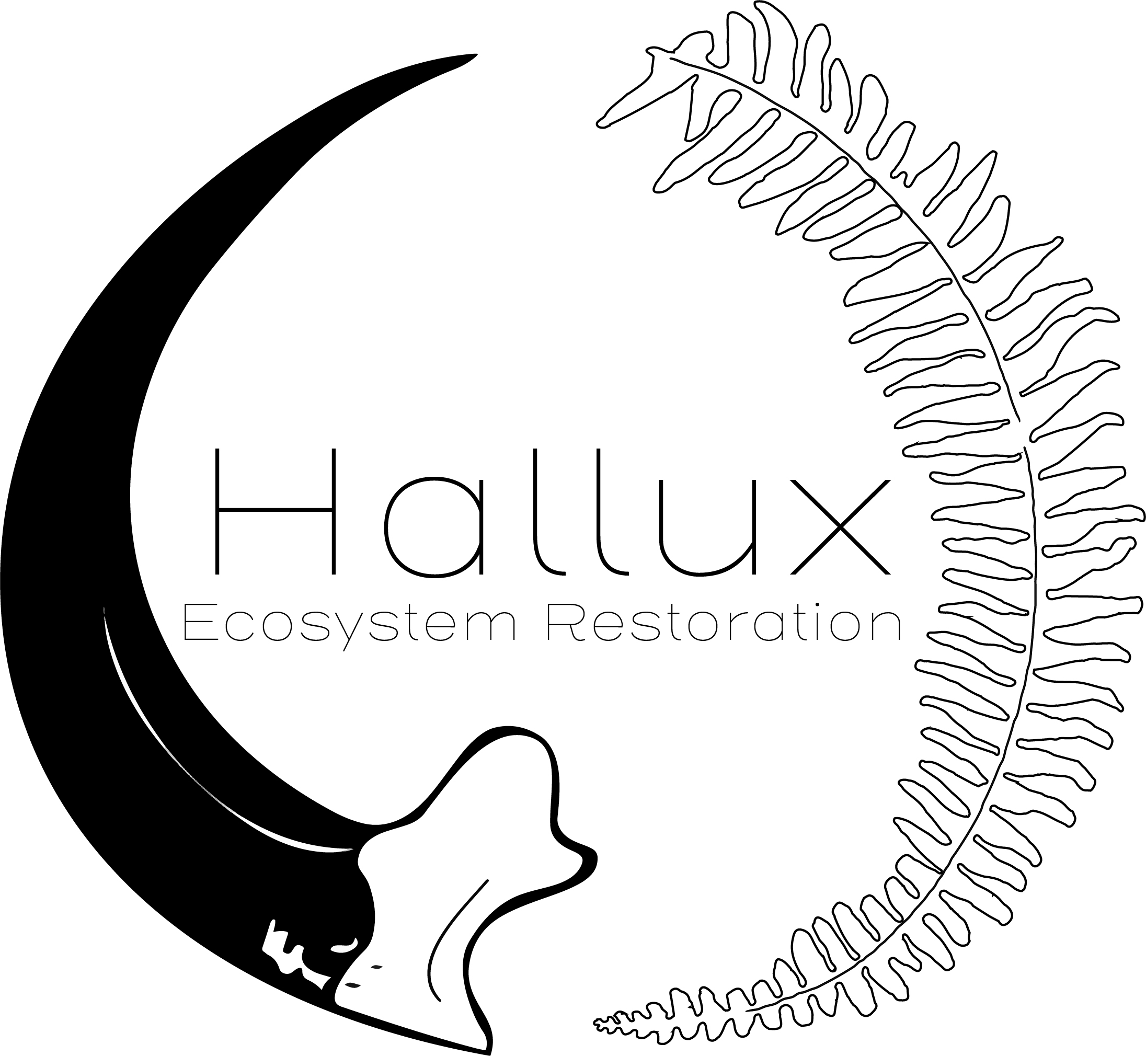

Job Title | Predator Control Specialist (5 open positions)
Project Assignment | Hono O Na Pali Seabird Mitigation Project
Salary | $35 - $39,000 (based on experience, performance)
Effective Date | March 12, 2019

- Summary of Duties: Regular, Full-time Predator Control Specialist position with Hallux Ecosystem Restoration LLC, located in Lihue, Kaua’i, HI, USA. Continuation of employment is based on work performance, program/operational needs, and compliance with applicable Federal and State Laws.

The Predator Control Specialist (PCS) monitors and controls non-native invasive vertebrates including feral cats, rats, mice, barn owls, and feral pigs within three endangered Hawaiian Petrel and Newell’s Shearwater colonies in the remote and rugged Hono O Na Pali (HONP) Natural Area Reserve on Kaua’i. S/He works under the direction of the HONP Seabird Mitigation Project Associate Biologist (AB), and the Hallux Ecosystem Restoration Lead Biologists (LB). The PCS operates, maintains and manages various types of traps for invasive mammals, and participates in hunting operations, following hallux Ecosystem Restoration standard operating procedures, safety protocols, state and federal laws and IACUC protocols. The PCS performs basic construction tasks and simple maintenance on traps, tools and vehicles, and assists with helicopter sling-load operations. S/He operates equipment such as Global Positioning Systems (GPS), handheld radios, cameras, telemetry, etc. Additionally, s/he collects detailed data in the field and enters data into databases. The PCS also assists in data proofing and the preparation of site maps and other tasks related to keeping accurate records of the fieldwork. All crew live and work in primitive conditions for up to eight (8) days at a time. The PCS provides supplemental information on distribution and breeding success rates of endangered seabirds within the study areas and occasionally assists with seabird monitoring work, as needed. S/He loads, unloads, aims, and fires handguns, shotguns, rifles and other authorized pellet guns or firearms from a variety of body positions in authorized project-related research or wildlife control programs.
Advancement within the Specialist position allows for up to four levels, each increasing in responsibility, required expertise, and compensation. Advancement through each level is evaluated and awarded based upon employee experience level within the company, job performance (both in the field and the office), trap handling skills and competence, biological knowledge and expertise, attitude, and advanced firearms training.

Summary of Specialist Levels:
- PCS 1: (Entry level)
  - Retention Time: 6 months, occasional exceptions made
  - Restrictions: No firearm use, requires supervision for new assignments
  - Specific Tasks: complete all assigned training courses to best of ability, utilize coworkers as resource to advance trapping knowledge and skills, and follow safety and trapping protocols
- PCS 2:
  - Retention Time: N/A
  - Qualifications: works independently, passes basic certifications, demonstrates proficiency in all trap types
  - Restrictions: Firearm use for trap dispatch only
  - Specific Tasks: advance personal expertise on specific trap types and removal methods, work independently on traplines, and follow safety and trapping protocols
- PCS 3:
  - Retention Time: N/A
  - Qualifications: proficient in all trap type, expertise in >4 trap types, demonstrates advanced knowledge/skills
  - Restrictions: Firearms use for trap dispatch only, supervised hunting with pellet guns
  - Specific Tasks: begin advanced firearms/hunting training, assist in hunting operations, work independently on traplines, and follow safety and trapping protocols
- PCS 4:
  - Retention Time: N/A
  - Qualifications: Certified urban sharpshooter for wildlife control, proficient in all traps, expert in >5 types
  - Restrictions: Able to use firearms with guidance of LB and AB
  - Specific Tasks: aid and lead hunting operations, schedule helicopter flights for planned trips, aid AB with trip preparation, and follow safety and trapping protocols

- Scope of the Position:
  - Reports to: HONP PC Associate Biologist, Lead Biologist (Alex Dutcher)
  - Supervises: None
  - Signature Authorities:
    - Receiving Supplies and Services
- Level of Interaction: Supervised by the HONP Seabird Mitigation Project Associate Biologist, who provides individual project goals and priorities with advising from the Hallux Ecosystem Restoration Lead Biologist (LB). Field duties take place on Hawai‘i Division of Forestry and Wildlife (DOFAW) land within the HONP Natural Area Reserve on Kauai. Works closely with various DOFAW personnel and equipment and interacts closely with personnel from the Kaua’i Endangered Seabird Recovery Project (KESRP). Communicates daily with AB to discuss status of projects and assist in planning future projects. Performs technical biological fieldwork requiring high degree of attention to detail for data collection, often under difficult field conditions. Work will focus on implementing the Memorandum of Understanding (MOU) between the State of Hawai‘i and the Kauai Island Utility Cooperative (KIUC), which consists of predator control and endangered seabird monitoring for the mitigation of endangered seabird take under Section 10 of the Endangered Species Act. Works independently with regular input provided by the Associate Biologist and occasionally from the Lead Biologist. Collaborates with KESRP staff where appropriate to inform trapping locations and monitoring methods.
Work must be in accordance with the State of Hawai‘i DOFAW and Hallux Ecosystem Restoration policies, management guidelines, and endangered species legislation. Evaluated on safety, effective progress, and quality of work. Person-to-person contacts are primarily with supervisors, fellow field crew members, KESRP staff, and occasionally landowners and local community members. Interacts with the public occasionally on an informal basis and will be expected to provide accurate information about the nature of the work in a professional manner. Work environment is in remote, mountainous conditions sometimes requiring helicopter travel and long, irregular hours including, night work. Attends training to gain or maintain skills in safe use of firearms, basic first aid, aviation safety, and other skills. Contributes to creating and preserving a safe and positive work environment. Good communication skills are essential. Must be able to conduct fieldwork in dense vegetation under difficult conditions (heat, rain, cold temperatures, poor footing). Fieldwork may involve elevation changes up to 4,500 feet in a day, often carrying heavy equipment.
- Major Duties and Responsibilities
  - Predator Monitoring and Control: Conducts predator control and monitoring for feral cats, rats, mice, barn owls, and pigs in the HONP Natural Area Reserve following Hallux Ecosystem Restoration standard operating procedures and safety policies, and IACUC protocols. Loads, unloads, aims, and fires handguns, shotguns, rifles and other authorized pellet guns or firearms from a variety of body positions in authorized project-related research or wildlife control programs. Performs these functions in a safe manner in varying environments and weather conditions. Disassembles, cleans, inspects and reassembles firearms. Maintains firearms and related equipment in a proper, functional, and safe manner. Assists in installing and monitoring trap and camera transects to collect, summarize, and analyze data on predator presence and abundance. Assists in the maintenance of accurate data on predator occurrences, trap days and capture rates, and uses GPS to map capture locations. Adheres to latest Rapid Ohia Death and biosecurity protocols, in order to protect the native ecosystems.
  - Performs basic construction and maintenance tasks: Under the supervision of the HONP Seabird Mitigation AB, performs trap maintenance and cleaning of tools, equipment, remote campsite facilities, and vehicles and notifies supervisors when major repairs or replacements are necessary. Completes basic construction tasks using hand tools to assemble trap boxes, basic weather port maintenance, and landing zone clearing. Tracks supplies and equipment inventories.
  - Installs and monitors remote trail cameras to collect data on predator presence and abundance in Hono O Na Pali Natural Area Reserve.
  - Attends training to gain or maintain skills in safe use of firearms, power tools, helicopters, First Aid/CPR, and other subjects related to the job. Provides supplemental information on distribution and breeding success rates of endangered seabirds within the study areas and occasionally assists with seabird monitoring work, as needed.
  - Attends training to gain/maintain up-to-date certification in helicopter safety, First Aid/CPR, firearms, and other subjects related to the job.
  - Performs other duties as assigned.
- Primary Qualifications:
  - Education/Training: Bachelor’s degree from an accredited four-year college or university in Biology, Natural Resource Management, Wildlife Management, or Environmental Science, with basic/related biology coursework. (A Bachelor’s degree in an unrelated field with at least two years of experience managing natural resources for the protection of threatened or endangered species, specifically involving predator control may substitute for a more wildlife-specific degree)
  - Experience: At least two (2) years of remote field work experience in natural resource management with a specific emphasis on natural resource protection. Experience must be well documented, and acquired while under the employment of an academic institution, governmental agency, private company or non-profit organization in the related field.
  - Knowledge: Knowledge of native Hawaiian flora and fauna and threats from alien species. Knowledge of the principles of ecology and wildlife biology. Must demonstrate knowledge of safe use of firearms and wildlife traps.
  - Abilities and Skills: Ability to use compass, map, and GPS hand-held units for navigation and data recording. Ability to take accurate and detailed data in the field and input data into a computer. Ability to communicate well both orally and in writing. Ability to work independently or in pairs in remote field settings. Demonstrate ability to euthanize trapped animals humanely. Basic mechanical and carpentry proficiency. Must possess a valid driver’s license (and if use of personal vehicle on the job is required, must also have valid personal driver’s insurance equivalent to Hawai‘i’s No-Fault Driver’s Insurance) and maintain throughout the duration of employment.
    - Post Offer/Employment Condition: Must possess the American Red Cross Certification in First Aid/CPR or be able to obtain and maintain the certificate prior to use of firearms on the job (whichever comes first) and maintain certification throughout duration of employment. Must be able to pass state and federal criminal history/record background check at initial hire, at change of job requiring use of firearms and annually, which legally enables possession and use of firearms and ammunition throughout duration of employment. Must obtain and maintain National Rifle Association or National Park Service firearms training (or other comparable training) and State of Hawai‘i/DLNR Hunter Education Training Program firearms certification. As a condition of employment, all certifications must be obtained and maintained as specified by the certifying agency or as required by state and federal laws. Failure to pass the firearms qualification requirements may be grounds for disqualification of part or all of the job duties. Must be able to complete basic helicopter safety course within six (6) months from date of hire.
  - Physical and/or Medical Demands: Ability to hike and camp in remote areas and rugged terrain under inclement weather conditions, up to eight (8) consecutive days. Ability to hike up to twelve (12) miles on irregular terrain with backpacks weighing up to fifty (50) pounds unassisted.
  - Policy and Regulatory Requirements: As a condition of employment, employee will be subject to applicable Hallux Ecosystem Restoration policies and procedures as applicable. Violations of Hallux Ecosystem Restoration policies/procedures and/or applicable IACUC, State or Federal laws may lead to disciplinary action (including, but not limited to, possible termination of employment, personal fines, civil and/or criminal penalties, etc.).
- Secondary Qualifications: Previous fieldwork experience with emphasis on invasive vertebrate trapping and control with a land management agency or a county, state, or federal program in Hawai‘i. Previous experience monitoring endangered Hawaiian seabirds. Experience using remote cameras to monitor wildlife. Experience working in and around helicopters. Experience in identification of native Hawaiian plants and animals, and non-native plants. Mechanic, fabrication, and carpentry skills are highly desirable.
- Reviewed by Incumbent of Position: This position description is a summary of job functions, responsibilities, and qualifications. These designations of functions are subject to change as needs dictate.

I, ________ certify that I have thoroughly read and understand my position description and related policies and will comply with the conditions outlined in each.

Employee Signature & Printed Name Date

Prepared and Approved by:

Lead Biologist Date

