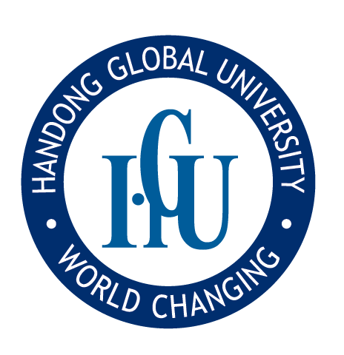
Vacancy Announcement of
Tenure Track Faculty & Non-Tenure Track Position
Announcement For Fall Semester 2016
Handong is God’s University – Cultivating God’s People, God’s Way

1. Vision and Educational Goals
- Cultivate honest Christian leaders who can transform the world with the spirit of love, humility and service, and glorify God.
- Raise honest global leaders who serve communities, nations, and the world, especially developing countries, through their professional skills and personal ethics.
- Train honest and competent intellectuals who re-establish the true purpose of education in various academic fields with a Christian world-view, and restore Biblical creationism and impaired morality. (Isaiah 58:12)
2. Available Positions Department
Status | Department | Major | Fields
Tenure  Track | Management and Economics | Economics | Macro / Micro economics
 | Communication Arts and Science | Performance and Film Arts | Digital Image Plan/Production
 | Counseling Psychology and Social Welfare | Counseling Psychology | physiological / Clinical / Counseling Psychology
 | Computer Science & Electronic Engineering | Computer  Science | Big data / Internet of Things(IoT) / Artificial Intelligence(AI), Computer Security, System S/W, etc.
 | Mechanical & Control Engineering | Control System Engineering | Mechatronics, Control Measurement Engineering
 | School of Global Entrepreneurship and ICT | Global Entrepreneurship | Business Start-up Education  / Business Consulting
 |  | ICT Convergence Major | Visual Media,  Virtual Reality/Augmented Reality(VR/AR)
 | Global Leadership School  (College of Liberal Arts) | Sociology | Sociology(in general)
Non-Tenure Track | Global Leadership School  (College of Liberal Arts) | ICT convergence basis | Practical Computing
The number to be admitted: ○ person per each area of recruitment

3. Qualification and preferred qualification
※ Qualification for applicant
A. Applicants must have a Ph.D. degree or be expecting to acquire a Ph.D. degree by the date of appointment (September 1st, 2016), and have no other disqualifying factors for appointment. Hiring will be revoked if those who are expected to acquire Ph.D. accepted before date of employment do not acquire until date of employment (September 1st, 2016)
B. By the application deadline standard, applicant who is registered in the National Research Foundation of Korea and has the Research record above 200% in the past 3 years (June 24th, 2013.～June 23rd, 2016). However, by the application deadline standard, applicant who get a doctorate in recent 6 months can apply with the research record above 100%.
※ Research result standard of computation
i. National Research Foundation of Korea 1st registration 100%, Doctorate thesis 100%, Forensic Science International (SCI, SSCI, SCIE, AHCI, SCOPUS) 1st 200%
ii. Research record recognition exchange rate: solo 100%, 2 persons 70%, 3 persons 50%, 4 persons above 30%.
C. Applicants must conform to and participate in realizing the university’s vision of whole person character education and evangelical Christian faith.
D. Applicants should be able to both view their major field of studies and teach students from a Christian perspective
E. Candidates should be able to lecture in English`

※ Preferred qualification
- Foreign applicant by the nationality standard
- Applicant of convergence education capacity (ICT connected education etc.)
- Applicant with experience of the related industry of the field.
- In case of School of Communication Arts and Science tenure track, Applicant who has more than 3 years’ practice experience about digital video plan and production.

4. Necessary Documents
A. Step 1 : Applying first, Submit following documents.
- One Application Form (Issued by HGU) : View attached File.
Fill out the form and submit it by e-mail. (kbs0627@handong.edu)
B. Step 2 : Selected candidates from Step 1 must only submit following documents.
- Two copies of transcripts and diplomas of all degrees (Bachelor’s, Master’s and Doctorate.)
- Two copies of confirmation of working experience (for the past 4 years only. When applicant becomes a finalist, confirmation of all work experience must be submitted.)
- Two carbon copies of license (if applicable)
- Two copies of list of accomplishments in research activities (Title, researchers, date of presentation, publication, synopsis of paper, etc.)
- Two copies of doctoral thesis(one carbon copy possible)
- Two copies (one carbon copy possible) of research papers since June 24th, 2013
※ Five representative papers for the past 3 recent years(Doctor’s thesis can be included)
- Two Recommendation Forms
- One Recommendation each from Major and Non-Major(Faith) recommenders
- Recommendation Form(Issued by HGU) : We will send the file to applicants who pass the Step 1.
- A recommender should fill out the recommendation form and submit it by e-mail(kbs0627@handong.edu) or mail directly.
- When a recommender sends it by e-mail, the title should be like this, “Recommendation_ the name of Applicant”. (Ex. If the name of applicant is “Michael Jordan”, the title of e-mail should be “Recommendation_ Michael Jordan”)

5. Application Procedures
- Application Period: Jun 3 (Fri), 2016 – Jun 23 (Thur), 2016 5:00pm
- Submission Method: Can be e-mailed
- E-mail : kbs0627@handong.edu
- Selection Process (Refer to HGU Homepage for detailed screening procedures and criteria)
  - Step 1: Document screening (Applicants will be notified of the result via e-mail or phone)
  - Step 2: Basic and advanced screening (This step is applied only to those who pass step 1. Applicants will be notified of the result via e-mail or phone)
  - Step 3: Interview (This step is applied only to those who pass Step 2. Applicants will be notified of the result via e-mail or phone)
  - Step 4: Interview with president of Handong Global University (This step is applied only to those who pass Step 3. Applicants will be notified of the result via e-mail or phone)

6. Others
- After appointment, finalists must deliver all lectures in English.
- The ability to embody a Christian perspective and teach students from this perspective should be proved in the self-introduction letter.
- Recruitments may not be made if there are no eligible applicants
- A finalist’s appointment can be canceled if the application form is found to be falsified.

7. For Information and Application
For further information, contact HGU’s Office of Academic Affairs.
∙ Address : Office of Academic Affairs, Handong Global University
558 Handong-ro, Heunghae-eup, Buk-gu, Pohang, Gyeong-buk, 37554
∙ Tel: (from Korea) 054-260-1077 (Official in charge: Beomseok Ko)
(from outside Korea) +82-54-260-1077
∙ Fax: 054-260-1079
∙ E-mail: kbs0627@handong.edu Homepage: www.handong.edu

